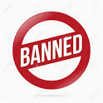

In sixth grade, we will focus on better word choices for our writing. The following words are BANNED!
They are ordinary and DO NOT appeal to the senses

Nice
Good
Bad
Like (except for similes)
A lot
Really
Kid
Stuff
Very
Thing
Okay

Verbs
Said/says/say
Got or Get
Went

We will add more banned words throughout the year….

THINK ABOUT strong adjectives and verbs to power your writing!

